Donor Report: Cover Letter Template
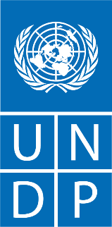

Ref: UNDP/[xxx]/[xxx]/[xxx]
28.10.2024
Dear [Name of donor signatory in the cost sharing agreement],

Subject: Project “Social Cohesion through Inclusive Zero Waste in Refugee Hosting Municipalities” Annual Progress Report

Reference is made to the contribution agreement between United States Bureau of Population, Refugees and Migration (PRM) and UNDP for the project “Social Cohesion through Inclusive Zero Waste in Refugee Hosting Municipalities” effective 1 September 2023.

I am pleased to submit herewith the Annual Progress Report for the abovementioned project.

The report summarizes the progress of the project between 1 September 2023 and 31 August 2024 and provides an overview of the achievements, challenges, lessons learned, interim financial status and way forward.

I thank United States Bureau of Population, Refugees and Migration (PRM) for its contributions to UNDP and look forward to strengthening our partnership in support of development in Türkiye.

<Signature>
Louisa Vinton
Resident Representative i
UNDP Türkiye

Attached: Social Cohesion through Inclusive Zero Waste in Refugee Hosting Municipalities Progress Report

[Name of donor signatory in the agreement]
[Title of the donor signatory in the agreement]
United States Bureau of Population, Refugees and Migration (PRM)
[City, country]
Reporting Period | 1 September 2023 – 31 August 2024
Donor | United States Bureau of Population, Refugees and Migration (PRM)
Country | Türkiye
Project Title | Social Cohesion through Inclusive Zero Waste in Refugee Hosting Municipalities
Project Locations | Adıyaman, Hatay, İzmir, Kilis, Mersin and Şanlıurfa provinces
Project ID  Outputs  Strategic Plan and/or CPD Outcomes | 01001629  Output 1.1. Displaced populations are equipped with the knowledge and skills to engage in the socioeconomic life of their host community.  Output 1.2 National/local institutions supported towards implementing the National Harmonization Strategy and its Action Plan  1.3: By 2025, people under the Law on Foreigners and International Protection are supported towards self-reliance
Implementing Partner(s) | The Ministry of Environment, Urbanization and Climate Change (MoEUCC)
Project Start Date | 4 July 2024
Project End Date | 31 August 2026
LPAC Date | 8 November 2023
Steering Committee/Project Board Meeting Dates | 21 November 2024
SDG linkages | SDG 8 – Decent Work and Economic Growth  SGD10 – Reduced Inequalities  SDG 12 – Responsible Consumption and Production
GEN marker | GEN1
(Year) Delivery to Budget Ratio | USD 2,800,000
[Year] Annual Work Plan Budget | USD 2,800,000
Total resources required | USD 8,400,000
Revenue received | Donor (PRM) USD 2,800,000  - Total USD 2,800,000
Unfunded budget | USD
UNDP Contact Person | Louisa Vinton  Resident Representative  UNDP Türkiye  Email: louisa.vinton@undp.org  Tel.: +90 312 454 1100

Executive summary

“Social Cohesion through Inclusive Zero Waste in Refugee Hosting Municipalities” project has been designed and being implemented to enable social cohesion through zero-waste practices. As vulnerable groups including the Syrians under Temporary Protection (SuTP) are involved in waste collection, increasing the positive perception, developing technical capacities and providing enabling equipment and facilities have been deemed important to achieve the project goals.

The initial year of the project had a budget of USD 2,800,000 and the main focus was on three pilot locations, İzmir, Kilis, and Şanlıurfa Haliliye. During the reporting period, needs assessments were conducted, negotiated and approved by all parties. Following the approval of the needs assessments, provision of required key equipment was initiated and mostly completed. Some equipment such as collection and degradation facilities, which requires longer time to establish have been initiated and will be completed in the second year of the project. To achieve the outreach targets and develop capacities, the Support to Life Association (STL) was contracted. In coordination with the implementing partner, UNDP’s field coordinators, municipalities as well as the government representatives, awareness-raising, capacity building and dissemination activities have been initiated. The agenda of the local partners and the implementing partner has been aligned through various coordination actions.

During this period 55 electrical waste collection tricycles, 3 mobile zero waste collection vehicles, 8 zero waste markets had been delivered to the municipalities and delivery of 3 solid waste disposal facilities, 2 mobile zero waste collection vehicles, 1300 personal protective equipment, 5366 composite recycling bins, 2 pickup vehicles for vegetable oil, medicines, and batteries as well as zero-waste management software are scheduled. To ensure social cohesion, awareness-raising, capacity building and consultancy activities had been designed and implemented. Individuals including Syrians under Temporary Protection, and vulnerable groups received thematic activities at 9 modules; zero waste management, household waste management, social inclusion (waste collection: risks and precautions in waste management, gender-based violence (GBV), child labor and prevention of early and forced marriages. A total number of 3,137 individuals received such services and 61 municipal staff had been trained for inclusive zero-waste.

The project was initiated during the local election preparations and the initial period was interrupted with elections, where most of the contact persons of the local partners changed. This foreseeable situation led to delays in project activities and with the experience in similar cases, newly elected mayors and technical staff were informed quickly and these issues related to delays have been overcome. Next steps of the project will be focused more on implementation of innovative and effective actions. With the equipment delivered and the awareness created, community wardens and individuals will be given a specific importance to ensure social cohesion and extend zero-waste through the community.

Background Information

Türkiye has established a strong policy foundation for environmentally sound waste management built on the principles of recycling, the circular economy and the ideal of “zero waste.” The Ministry of Environment, Urbanization and Climate Change (MoEUCC) undertook a Zero Waste Project in 2017, and in 2019, prepared a By Law on Zero Waste aimed at creating a zero-waste management system focused on protecting the environment, human health and natural resources. The policy framework and awareness-raising campaigns have already helped to double the volume of waste recycled.

Municipal waste management systems in Türkiye have come under stress over the past decade. The increase in waste caused by the influx of millions of Syrians has stretched the capacity of municipalities hosting large numbers of refugees and tested social cohesion. Waste management is one of the largest municipal budget lines. Further, waste management services suffered from the destruction caused by the earthquakes of February 2023The earthquakes destroyed municipal equipment and infrastructure across 11 provinces, and many municipalities that escaped extensive physical damage (such as Kilis) saw waste pressures increase with the arrival of earthquake survivors seeking shelter.

Zero waste policies can have an important social impact given both their impact on community wellbeing and on the significant number of individuals who earn a livelihood from collecting recyclable waste. In supporting municipalities to implement zero-waste strategies at local level, the MoEUCC strives to ensure that earnings from recycling benefit the most vulnerable while promoting the registration of waste pickers and the formalization of their work status.

A significant amount of waste collectors in Türkiye are refugees or migrants. Kilis Municipality, for example, hosts 600-700 waste collectors, 80 percent of them Syrian. Supporting municipalities in implementing zero waste policies thus also offers a channel to improve the lives and livelihoods of vulnerable individuals and families.

In this context, the project supports the implementation of national zero waste policies in municipalities that have experienced a large refugee influx while also addressing the consequences of the 2023 earthquake disaster. The goal is to help municipalities to reduce the environmental cost and social burden of waste by promoting recycling and other circular economy concepts, while also helping municipalities improve the social situation of waste collectors.

Progress Review

The project aims to support vulnerable populations, mainly Syrians under Temporary Protection and low-income Host Community Members by vesting them with skills and awareness to get officially involved to the zero-waste ecosystem. SuTP and other vulnerable groups including the women, the young, persons with disabilities are being supported to participate in the labour market and social life. With a thematic approach of zero-waste, where such groups are already involved, decent working conditions and registered employment are aimed to be increased.

The project contributes to Türkiye Country Programme Document’s (CPD) outcome “By 2025, Persons under the Law on Foreigners and International Protection are supported towards self-reliance". Under this outcome, two outputs are being contributed with the project, (i. output 1.1) “individuals under LFIP have the knowledge, skills and opportunities to engage collaboratively with others in their communities and achieve self-reliance" and (ii. output 1.2) national/local institutions supported towards implementing the National Harmonization Strategy and its Action Plan”.

Under output 1.1 of the CPD, 879 individuals among SuTP have been trained for zero-waste, enabling them to gain skills and knowledge regarding the technical aspects and the official procedures. As this progress was reported within the initial year of the three-year long project, both the number of trained individuals and registered ones are expected to increase significantly. For the output 1.2, 8 municipalities and the Ministry of Environment, Urbanization and Climate Change received awareness, and these municipalities were provided zero-waste action plan covering cohesion strategies.

The progress under each output and activity are indicated below:

Output 1: Targeted municipalities effectively implement community-based best practices in zero waste, by expanding the zero-waste markets, incentivization schemes, and equipment support, while fostering inclusion

Under Activity 1.1, “setting up zero-waste markets and incentive schemes in targeted municipalities”, a comprehensive zero waste management needs analysis was initially started with Haliliye, Kilis, and Konak Municipalities in March 2024 to evaluate the establishment or improvement of existing zero-waste incentive systems and to better prioritize resource distribution and address the specific needs identified in each municipality, which had been completed and approved as of June 2024 (Annex 3). The project initially focused on Haliliye and Kilis, as they were included in Phase 2 of the project. In Haliliye, the existing framework for zero-waste markets, introduced during Phase 2, had been quite successful. Originally limited to one zero-waste market, the municipality extended the number of zero waste markets to three across different neighborhoods within its borders.

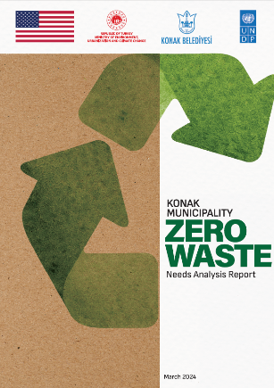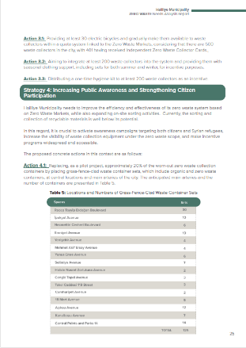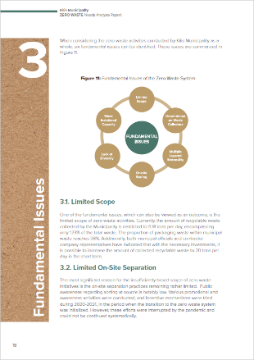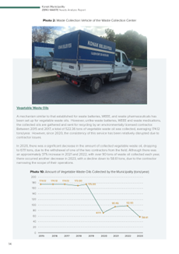
Figure 1 – Needs Assessment Reports

Konak Municipality had previously initiated zero-waste practices starting in 2019, but further improvements were required to expand these practices into more comprehensive incentive schemes and market setups. The readiness with tripartite management involving the municipality, a contractor company, and a waste collectors' cooperative positioned Konak as a priority municipality for advancing zero-waste initiatives under the project.

The needs analysis for the remaining target municipalities (Adıyaman, Besni, Antakya, Reyhanlı and İskenderun) was initiated in August 2024, with both fieldwork and draft reports are completed. Although still in draft form by the date of this report, these reports provide valuable insights for the project, offering a forecast for the allocation of resources required for the procurement of essential equipment and services.

Following the needs analysis conducted for the first three municipalities, namely Haliliye, Kilis and Konak, the procurement processes for both fixed and mobile zero-waste markets were initiated in July 2024. As of the date of this report, the manufacturing phase has been successfully completed, with the markets set to be ready once the logo design is finalized. The markets will be delivered to the designated municipalities upon transfer to the targeted locations.

In addition to the zero-waste management needs analysis, a separate contract was signed with an independent consultant in March 2024 to develop new or enhance existing incentivization schemes. These schemes will be supported by a shared software infrastructure accessible by all municipalities benefiting from fixed and mobile zero-waste markets. The situation analysis for the incentivization schemes was finalized in August 2024 and the needs assessment along with the technical specifications for the software are currently under review to further proceed with the procurement process. The software is expected to be used both by the municipality personnel, local users of the scheme, waste collectors (if applicable) and residents of the municipality.

Based on the zero-waste management and incentivization scheme needs analysis, as well as discussions with the municipalities and coordination with the Ministry, fixed and mobile zero-waste markets are planned to be delivered to the municipalities shown in Table 1. This plan is aligned with the available budget distribution and aims to optimize resource allocation across the targeted municipalities.

Municipality | Fixed Zero Waste Market | Mobile Zero Waste Market | Incentive System Software
Konak | 2 | 1 | 1
Kilis | 0 | 0 | 1
Haliliye | 3 | 1 | 1
Adıyaman | 0 | 0 | 0
Besni | 1 | 0 | 0
Antakya | 0 | 1 | 1
Reyhanlı | 1 | 1 | 1
Iskenderun | 1 | 1 | 1
TOTAL | 8 | 5 | 6
Table 1 - Planned Delivery Zero-Waste Markets by Municipality
Under Activity 1.2, “providing additional equipment to enable municipalities to implement zero-waste policies”, the zero-waste management needs analysis mentioned under Activity 1.1 has highlighted the needs of the municipalities. This analysis provides insights into the gaps and requirements necessary for each municipality to successfully implement and expand their zero-waste initiatives, not only under the limited scope of this project but to fully identify the specific equipment and infrastructure needs to allocate resources and deliver tailored solutions.

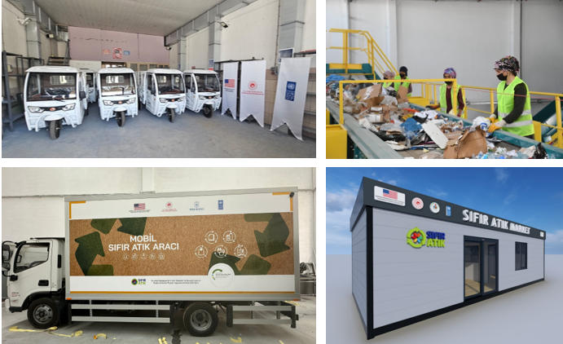
Figure 2 – Visuals of equipment provided or to be provided.

Although the needs of the municipalities are varied ranging from equipment and facilities to services aimed at the long-term improvement of their zero-waste management systems, the project has focused on prioritizing the equipment and facilities that will provide the most immediate returns for the related municipalities to comply with the national requirements. For this reason, the procurement efforts have primarily concentrated on essential infrastructure and equipment limited by the budget. The additional equipment to enable municipalities to implement zero-waste policies include:

- Solid waste sorting facility to enhance the quality and quantity of recyclable waste which is currently manually sorted and stored in large waste sacks before being transported for recycling.
- Infrastructure equipment and first batch of consumables for fixed and mobile zero-waste markets to support the incentivization scheme and raise the awareness of the residents.
- Zero waste management system to enhance organizational capacity towards zero waste management and effective management and tracking of the waste that will enable real-time, spatial, and comprehensive data production.
- Composite recycling bins to increase recyclable waste from schools, apartment buildings, and public institutions and raise awareness for zero waste.
- Electric tricycles for the use of waste collectors and municipal personnel both to promote registration of waste collectors and enable efficient transfer of recyclable waste between locations.
- Vehicles for waste materials that require special transfer and treatment such as used vegetable oil, waste medicines, and waste batteries.
- Repair of current zero-waste management and recycling equipment.

The numbers of equipment and facilities that are planned to be provided to the municipalities are given below:

Municipality | Electric tricycles | Solid Waste Disposal Facility | Fixed Zero Waste Market (including infrastructure and first consumables) | Mobile Zero Waste Market (including infrastructure and first consumables) | Composite Recycling Bin | Zero Waste Management Information System | Pickup vehicle for vegetable oil, medicines, and batteries
Konak | 8 | 0 | 2 | 1 | 1000 | 0 | 0
Kilis | 5 | 1 | 0 | 0 | 0 | 0 | 0
Haliliye | 3 | 0 | 3 | 1 | 3000 | 0 | 0
Adıyaman | 7 | 1 | 0 | 0 | 0 | 0 | 0
Besni | 6 | 0 | 1 | 0 | 0 | 1 | 1
Antakya | 9 | 1 | 0 | 1 | 620 | 0 | 0
Reyhanlı | 7 | 0 | 1 | 1 | 746 | 1 | 0
Iskenderun | 0 | 0 | 1 | 1 | 0 | 1 | 1
TOTAL | 45 | 3 | 8 | 5 | 5366 | 3 | 2
Table 2 - Planned Delivery Additional Equipment by Municipality
The figures presented in the table represent the projected quantities for each municipality. However, as procurement for all equipment has not yet been finalized, some of these planned numbers may adjust based on the budget allocations for each municipality. Additionally, ongoing coordination with the municipalities and the ministry allows for flexibility in responding to any immediate needs that may arise. The delivery status of the equipment is being carefully monitored through a detailed online tracking system in collaboration with the ministry, ensuring real-time updates and transparency throughout the process.

The status for each group of equipment by the date of this report is provided in the table below:

Equipment | Status
Electric tricycles | The procurement process of 55 tricycles has been successfully completed, with 8 tricycles delivered to Konak, 5 to Kilis, 3 to Haliliye and 7 to Reyhanlı. Delivery to other locations is being coordinated. 10 tricycles that are not planned for any municipality will be allocated in line with the budget limits for each municipality based on other procurement.
Solid Waste Disposal Facility | Market research has been completed. Procurement process is ongoing. The facility requires accreditation by the related authorities. Coordination meetings have been conducted with the Provincial Directorates of Environment, Urbanization and Climate Change. The municipalities will provide the building and operating infrastructure and cover the running costs.
Fixed Zero Waste Market (including infrastructure and first consumables) | The procurement process of 8 fixed zero waste markets has been completed. Manufacturing of the markets is ongoing. Basement will be completed at the locations to be provided by the municipalities.
Mobile Zero Waste Market (including infrastructure and first consumables) | The procurement process of 3 mobile zero waste markets has been completed and 2 of them have been delivered to Haliliye and Reyhanlı. Logo dressing is finalized for the 3rd vehicle.
Composite Recycling Bin | Market research and design have been completed. The procurement has been initiated for Haliliye. The procurement for other municipalities will be started in coordination with the related municipalities.
Zero Waste Management Information System | The need for zero waste management information system was identified in the last needs assessments. The procurement will be started in coordination with the related municipalities.
Pickup vehicle for vegetable oil, medicines, and batteries | The need for zero waste collection pickups was identified in the last needs assessments. The procurement will be started in coordination with the related municipalities.
Table 3 – Procurement Status of Additional Equipment

Under Activity 1.3, “supporting municipalities in complying with the “Decree on Waste Collectors,” in particular with the registration of waste collectors, providing materials, equipment and personal protective equipment (PPE) to waste collectors”, the procurement of Personal Protective Equipment (PPE) has been tendered, while the procurement process for hygiene kits is ongoing with micro purchase from local suppliers. The quantities planned for each municipality based on the needs analysis is provided in the table below:

Equipment / Municipality | Personal Protective Equipment | Hygiene Set
Konak | 200 | 100
Kilis | 100 | 100
Haliliye | 200 | 200
Adıyaman | 170 | 170
Besni | 70 | 70
Antakya | 100 | 100
Reyhanlı | 0 | 0
İskenderun | 500 | 500
TOTAL | 1340 | 1240
Table 4 – Distribution of Additional Equipment by locations

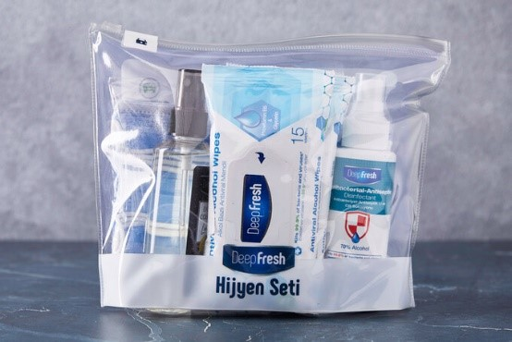
Figure 3 – Hygiene set and PPE examples to be provided.

Municipalities are facing challenges in registering waste collectors, primarily due to the informal nature of the work and difficulty in reaching and identifying all active collectors. The needs analysis indicates that many Syrians under Temporary Protection (SuTPs) involved in waste management are reluctant to register due to concerns about this process, although separate from employment registration, could risk their existing government-provided benefits in case they become registered employees. This concern is a major barrier in front of formalizing their status under the municipal records. However, being registered to municipalities as registered waste collectors does not result in the cancellation of social safety net, conditional cash transfer, or any other kind of aids. To address these challenges, efforts are being made to build trust relationship with waste collectors and leaders within their communities and mostly planned for the second year of the action to enhance social cohesion and provide support for the registration process by closely collaborating with both the municipalities and collectors. These efforts include reaching waste collectors and briefing them about the process to eliminate their concerns both through the municipalities, cooperatives and social cohesion activities. The equipment and materials to be provided, including the electric tricycles mentioned under Activity 1.2, are positioned as an incentive for registration, aimed at encouraging collectors to participate in the formal system. The aim is to not only meet compliance needs but also to foster improved working conditions for waste collectors while promoting social cohesion.

Capacity-building activities have also been initiated, including training sessions for municipal personnel to improve their understanding of waste collector registration requirements and compliance measures. This is intended to help ensure that all personnel involved are well-equipped to facilitate the process efficiently. Moving forward, a follow-up of these efforts will be carried out using the first-year statistics, allowing for better monitoring and evaluation of the program's effectiveness.

Under Activity 1.4, “providing capacity building support on zero-waste approaches and refugee-focused social outreach”, following progress have been achieved.

Improving the capacity of targeted municipalities staff on the zero-waste approach and outreach towards disadvantaged groups in general with a particular focus on the refugee communities is one of the very important activities identified under the project. Building on the results of this activity human resources of the target municipalities will gain a strong capacity to both have a refugee informed service provision and to disseminate zero-waste practices in their target communities.

In this regard, in Konak, Kilis, and Haliliye municipalities staff providing services under zero-waste management, social aid and support, women and family branches were targeted. Training modules were prepared on several topics regarding zero-waste practices such as zero-waste management, management of domestic waste, environmental consciousness. Several training modules on the protection concerns that affect the refugee population were also designed as child labour, early forced marriages, and gender-based violence. In total 61 (in Izmir 15, in Kilis 22 and in Şanlıurfa 24) municipality staff participated to trainings.

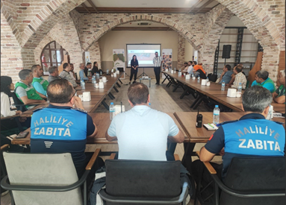 | 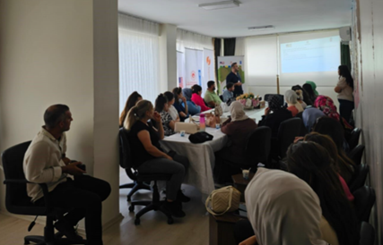
Figure 4 – Haliliye Municipality – Gender-based Violence | Figure 5 – Kilis Municipality – Social Cohesion and Waste Collection & Risks of Waste Collection Training

Output 2: Community cohesion in targeted municipalities improved by using the power of community-based waste management initiatives encouraging positive and solidarity-promoting behaviors amongst residents.

Under Activity 2.1, “conducting an assessment of recycling and waste disposal behaviors, community perceptions and needs related to solid waste, waste disposal and recycling”, following progress have been achieved.

In order to have closer look to communities’ recycling and waste disposal practices, perceptions and need regarding the solid waste and waste disposal behaviors a focus groups discussion were held in İzmir on 26 July 2024, with the participation of representatives from Ministry of Environment, Urbanization and Climate Change, officers from the Provincial Directorate of Environment, Urbanization and Climate Change, directors of Zero-Waste and Women and Family Directorates of Konak Municipality, deputy mayors of Konak Municipality, service providers to refugee and host communities, NGO representatives, and UNDP. There were 18 participants in total. The main discussion points were:

-Waste Management in Konak District: The roles of the local population, Syrians under temporary protection, and other migrant groups in waste management and zero-waste practices and observations within the scope of waste production, collection, and processing.

-Promoting Zero-Waste Practices: How zero-waste practices can be promoted across different socioeconomic groups and inclusive and creative solution suggestions.

-Working and Living Conditions of Waste Collectors: Recommendations for improving the working and living conditions of households involved in waste collection.

In line with these main discussion points various waste management issues that affect host and refugee communities were addressed. The high volume of the waste produced by households and businesses underlined as a major issue. Unlicensed and illegal waste collection sites and depots pose serious hygiene, security, and environmental risks due to ineffective regulation and integration. The meeting also emphasized the issues faced by disadvantaged populations including refugees and the poor, who are increasingly collecting waste for revenue. Participants reported various infrastructural and systemic issues that worsen waste management, such as few or damaged garbage containers and ineffective collection systems. Also crucial is the social attitude of waste collectors, who are often alienated from society despite their vital function in waste management. Due to the dangerous waste collection practices and social exclusion, women and children engaged in waste collection addressed with a special focus as a group at risk.
Many solutions were presented for these concerns. First, registering informal waste collectors would legalize and improve their working conditions. Integrating uncontrolled depots into formal waste management systems may speed up processes. Improving infrastructure was also important, with Zero Waste Markets and mobile and fixed waste collection equipment recommended. Dual collection systems and containers for organic and recyclable waste were suggested to boost efficiency. School programs and community awareness campaigns were suggested for zero-waste engagement. For vulnerable groups including women and children, social cohesion initiatives were suggested to improve their social integration and working conditions. Some best practices were also mentioned during the focus group discussion. Kapıda Dönüştür (Recycle at the Door) project, which involved household in collecting waste at home, effectively motivated local communities. Collaboration between local governments, NGOs, and waste collectors was also agreed to be crucial to creating a more inclusive and sustainable waste management system.
The focus group discussion was very fruitful not only to assess the current practices of refugees and host communities towards zero-waste and social cohesion but also building bridges and seeding future collaborations among crucial stakeholders in İzmir to implement initiatives aimed at fostering social cohesion and zero-waste practices for refugee and host communities. Similar meetings will be organized in other project locations to assess local dynamics in each district and understand similarities and differences to build a platform to learn together and share best practices. Moreover, a second round of focus group discussion will be organized at the last quarter of the project to assess the level of development and project’s contribution to social cohesion and zero-waste practices in target districts.

The needs analysis reports for zero waste management also constitute a baseline for recycling and waste disposal behaviors and community perceptions. Although distinct for each municipality, the findings indicate that while awareness of zero waste initiatives is notable, challenges persist in expanding on-site separation practices, particularly due to the socio-economic diversity of the communities and daytime population variations. The reliance on informal waste collectors and a lack of community awareness about proper waste separation significantly limit the effectiveness of recycling efforts. Accessibility issues and a lack of diverse collection initiatives hinder broader engagement.

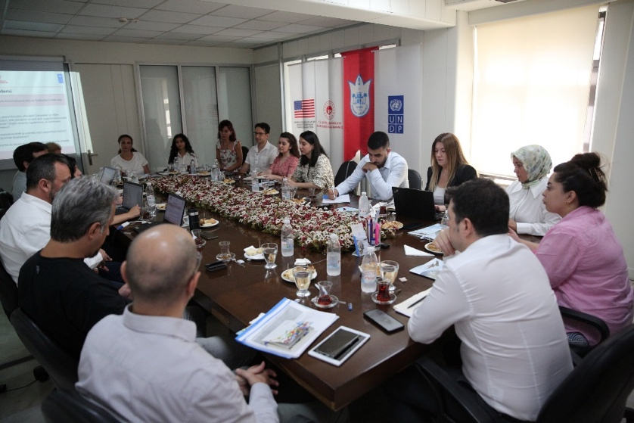
Figure 6 – Focus Group Meeting, Konak, 26 July 2024
Besides, it was identified that the government partners are particularly reluctant to use explicit surveys as a method for collecting data, largely due to concerns around the sensitivity in terms of social tension between refugee and host communities and potential backlash in the existing social cohesion level. As a result, the assessment approach was adjusted to ensure a balanced representation of perspectives while avoiding direct questioning that might influence social attitudes adversely. Starting from the second year of the project, the participants of widespread social cohesion sessions will be formed by the sample groups of the perception analysis. In addition, qualitative methods like focus group discussions were favored to gather more nuanced insights, allowing participants to express their perspectives more openly and comfortably without the risk of fueling pre-existing biases.

Under Activity 2.2, “conducting a social cohesion outreach campaign on zero waste”, in the first year of the project, community social cohesion outreach was initiated in İzmir Konak, Kilis and Şanlıurfa Haliliye as of June 2024. As indicated in the project plan community wardens from the refugee and host communities were targeted as well as the residents in general to multiply the impact of the social cohesion outreach activities.

A total of six training modules were prepared for the social cohesion activities. The aim of the training modules are both to increase the awareness of refugee and host communities on waste issues such as zero-waste and management of the household waste and social phenomena such as discrimination and risks of waste collecting. Coordination and collaboration among project parties contributed to formation strong and well-prepared training modules. For example, the Ministry of Environment, Urbanization and Climate Change specialists reviewed the zero waste and household waste management training modules and organized an information transfer session on the technical issues. The titles of the training modules are;

- Zero Waste Management
- Household Waste Management
- Social Inclusion: Waste Collection: Risks and Precautions in Waste Management
- Gender-Based Violence (GBV)
- Child Labor
- Prevention of Early and Forced Marriages

Trainings and information dissemination sessions around these topics were delivered community wardens who were selected precisely to represent different groups from refugee and host communities. A total of 243 community wardens were trained through the project’s community warden training sessions. The participants included volunteers, teachers, qualified instructors, mukhtars, youth representatives, NGO representatives, women’s cooperative workers, and community opinion leaders. Community wardens played an important role in the dissemination of the social cohesion messages to greater community. The sessions conducted by community wardens and Support to Life Association reached 2,875 unique individuals.
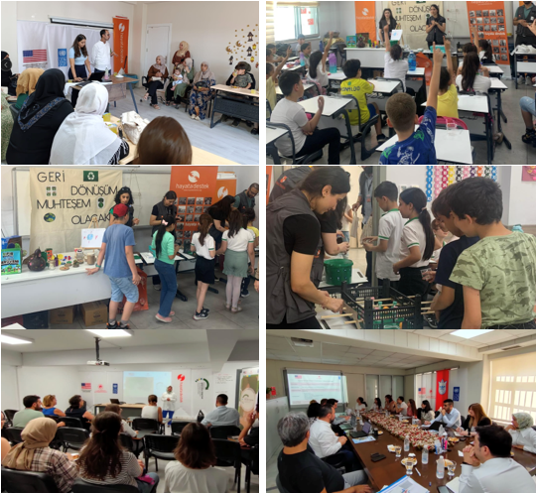
Figure 7 – Social cohesion activities - zero waste trainings.
An interactive method followed during the delivery of the session in order to ensure the better engagement of the participants with the topics. For the sessions with the adult target open-ended questions and group work were two mostly visited methods. In the sessions held with children, different methods such as drawing, crafting, and playing games around the addressed issues were facilitated.

During the implementation of community warden trainings and social cohesion outreach activities with wider community host community and Syrian community members targeted within the same sessions to promote the social cohesion messages. Organization of the activities followed closely by a collaboration between UNDP, STL and MoEUCC via an online planning and reporting document.
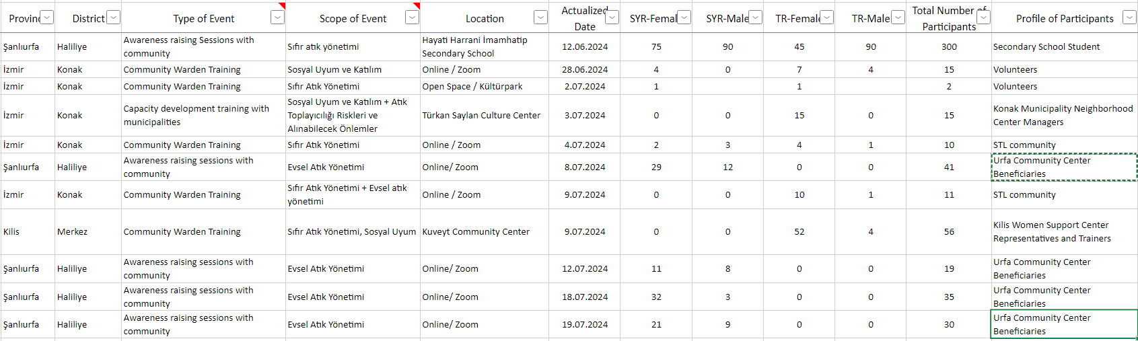
Table 5 – List of Events and Trainings

Under Activity 2.3, “supporting civil initiatives through municipalities collaborating with municipalities on solid waste management”, initial steps of the activity have taken place in the first phase of implementation period although the activity was planned to be implemented starting from the second year of the project.

The waste collector cooperative titled as İzmir Çevreci Atık Toplayıcıları Kooperatifi (İzmir Environmentalist Waste Collectors Cooperative) ÇETOKOOP was contacted to understand the operation capacity, member distribution and the needs of the cooperative. After the local elections the renewal process of the memorandum of understanding between Konak Municipality was followed closely.

In the meetings that were held with the ÇETOKOOP, it is learnt that the cooperative has more than 300 members and some of the members are Syrians under temporary protection. When the challenges of the cooperative members and waste picker in Konak in general questioned, inadequate housing conditions, being registered to another city than İzmir and lack of information appeared as the main challenges at the contact.
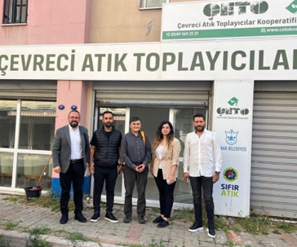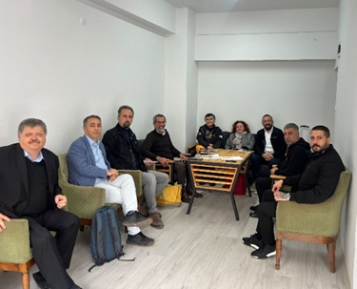
Figure 8 – ÇETOKOOP Meeting, 02.05.2024 Figure 9 – ÇETOKOOP Meeting, 12.02.2024

Following the guidance provided by the Ministry, it is planned to extend support to cooperatives through municipalities, utilizing either their existing partnerships or establishing new forms of collaboration. In İzmir, the municipality signed a contract on waste collection, transportation and sorting with a private company as a supportive activity of the project. This capacity will enable further collaboration between the municipality and ÇETO cooperative as the municipality became able to process the collected waste. Moreover, the project team is planning to coordinate selling some goods produced by women cooperatives and association. Some initiatives about this issue are as follows,
- Organic olive oils produced by the “Kilis Organic Olive Producers Association”, as well as the products of the “Women's Cooperative” making olive oil soap within the same compound, will be distributed to citizens in exchange for recyclable waste at Zero Waste Markets,
- Providing the culinary and artisanal products of the “Kadınhan Women’s Cooperative” in Kilis to the public at Zero Waste Markets in exchange for recyclable materials.

Communications and Visibility

A communication plan has been developed to ensure comprehensive visibility of the project and effectively convey its objectives, progress, and impact.

Within the framework of this plan, communication efforts are being carried out in alignment with the project's activities. Initially, a news piece detailing the project has been prepared for sharing on the UNDP website and social media accounts.

Social media posts related to the project activities have also been shared across all UNDP Türkiye social media platforms (X, Instagram, LinkedIn, and Facebook). To date, 5 posts have been shared about training and awareness-raising activities for effective zero waste management, as well as the İzmir field visit, both in Turkish and English. These posts on Instagram received over 24,000 views and around 500 interactions, while they garnered more than 10,000 views on X.

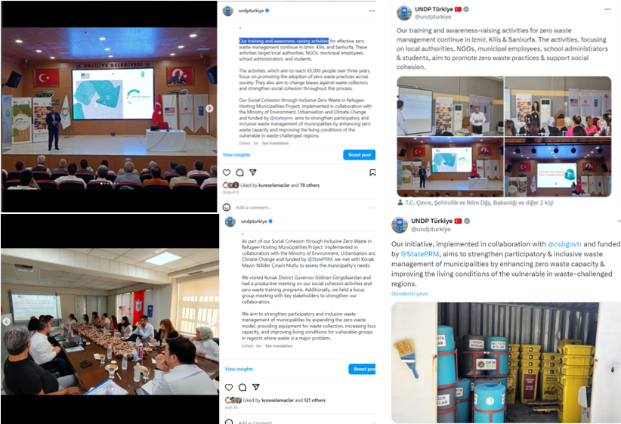
Figure 10 – Social media posts.
Donor visibility is being appropriately ensured in these posts. In the coming period, social media posts will continue about significant developments such as vehicle deliveries, project events, training sessions, and field visits.

Challenges and Best Practices

Bureaucratic challenges in the decision-making process create difficulties for the project team in executing activities and delivering products, leading to delays in vehicles and equipment procurement and activity implementation.

The project activities faced some delays primarily due to the local elections held in March 2024. Both the pre-election preparations and the subsequent staff changes impacted the execution of project activities, as the elections led to significant shifts in both administrative and technical teams. These changes, although anticipated by the project, disrupted decision-making processes and affected operations, necessitating adjustments to the original implementation timeline particularly due to lack of access to data.

To keep project activities on track and on schedule, activities related to community outreach, initially scheduled for the second year, were pushed forward and initiated in the first year. This proactive approach aimed to minimize the impact of delays and keep the project on track. During the approval phase of project, the actual initiation of activities were also faced risks of delays. To overcome this, activities were designed in detail and made ready for quick initiation and implemented successfully as soon as legal procedures are completed.

Is the “output targets and results” as well as “activities” section of your ATLAS module updated according to this Progress Report? Yes/No
- Yes

Indicator Based Performance Assessment
Using the Project Results Framework from Log frame of the Project Document - provide an update on the achievement of indicators at both the output and outcome level in the table below. Where it has not been possible to collect data on indicators, clear explanation should be given explaining why, as well as plans on how and when this data will be collected.

Level in Results Hierarchy | Description | Indicators | Baseline | Annual target | End of project target | Cumulative Realization (Number or Text) | Explanation for deviation from the target and any other remark (please break-down into male/female if possible)
UNSDCF Outcome |  | #1.3: By 2025, people under the Law on Foreigners and International Protection are supported towards self-reliance  Percent of strategic priorities/interventions of the Harmonization Strategy implemented | 0 | NA | %80 | N/A | -
Output 1 | Targeted municipalities effectively implement community-based best practices in zero waste, by expanding the zero-waste markets, incentivization schemes, and equipment support, while fostering inclusion | 1.1 Amount of PRM humanitarian funding distributed to municipalities | 0 | TBD | TBD | N/A | -
Output 1 |  | 1.2 Number of individuals reached with WASH activities through PRM funding (without double counting across disaggregates) | 0 | 6,750 | 138,860 | 3,137  (59% Female)  (29% SYR) | -
Output 1 |  | 1.3 Number of informal waste collectors registered by targeted municipalities | 0 | 100 | 900 | [TBC] | Following the elections on March 2024, the systematic for measuring is being established by the municipalities.
Output 1 |  | 1.4 Number of neighborhoods using zero waste best practices in each municipality | 0 | 15 | 30 | 9 | 9 neighborhoods in Haliliye benefit from zero-waste incentives; Devteyşti, Süleymaniye, Ahmet Yesevi, Bağlarbaşı, Şehitlik, Şair Nabi, Bamyasuyu, Paşabağı, Sancaktar Neighnorhoods
Output 1 |  | 1.5 Number of incentive schemes newly designed/ expanded and operational (excluding Phase II) | 0 | 0 | 7 | 0 | The existing systems that municipalities use had been assessed and the updated needs were defined. The incentive system will be designed and activated in 2025.
Output 1 |  | 1.6 Number of municipal staff participated and successfully completed trainings through PRM funding | 0 | 70 | 210 | 61  (52% Female) | Izmir 15, Kilis 22 and Şanlıurfa 24
Output 1 |  | 1.7 Percentage of trainees who report increased knowledge/ awareness | 0 | 80% | 80% | N/A | Post test are being conducted to participants and pre-tests are being conducted through community wardens.
Output 2 | Community cohesion in targeted municipalities improved by using the power of community-based waste management initiatives encouraging positive and solidarity-promoting behaviors amongst residents | 2.1 Number of individuals reached with socio-cultural and social cohesion activities through PRM funding | 0 | 0 | 90,000 | 3,118 | 2,875 is the total number of participants participated in awareness raising and social cohesion activities including the beneficiaries reached through the community wardens who were trained through the project (243).
Output 2 |  | 2.2 Number of HH members of waste collectors increasing information and referrals to social services following registration of waste collectors | 0 | 800 | 5,600 | 4  3 children + 1 adult 100% Male | It takes longer time to establish any direct trust relation with the waste pickers. Thus, community wardens are being mobilized for this purpose. Preliminary work has been done and within the second year of the project, direct interaction will be established for proceeding.
Output 2 |  | 2.3 Number of households registered to incentivization scheme in targeted municipalities / districts | 0 | 5,000 | 40,000 | [TBC] | Following the elections on March 2024, the systematic for measuring is being established by the municipalities.
Output 2 |  | 2.4 % of incentive card holders satisfied with incentives provided | 0 | 80% | 80% | N/A | A survey will be conducted in following phases of the project
Output 2 |  | 2.5 Number of community wardens:  a) trained  b) reported improved knowledge/awareness | 0 | a)500  b)400 | a) 3,000  a) 2,400 | a) 243 (58% Female)  b) [TBC] | A survey will be conducted in following phases of the project
Output 2 |  | 2.6 Number of civil initiatives provided with capacity building, and awareness raising activities | 0 | 0 | 2 | 0 | -

Contribution to Gender Equality

The project made significant contributions to gender equality and social cohesion through its gender-sensitive training modules and targeted interventions. Training sessions on gender-based violence, the prevention of early and forced child marriages, and waste collection risks and precautions raised awareness about the challenges faced by women, including female waste collectors. Of the 243 community wardens trained, 59.7% (145 participants) were women, demonstrating the project's commitment to promoting leadership roles for women. Additionally, 30.6% (879 individuals) of those reached in awareness-raising sessions were Syrian refugees, and 59% (1696 participants) were women, further emphasizing the gender-sensitive approach.
Moreover, social support mechanisms were designed with a focus on the needs of women and children, ensuring sensitivity to their vulnerabilities. By engaging both refugees and host communities, the project successfully fostered gender equality and social cohesion, contributing to its overall impact in the targeted municipalities.
- Monitoring Arrangements

Monitoring of projects activities is being followed up by M&E Associate of UNDP Country Office. Monthly progress data is being submitted by contractor (STL) and project team. Outputs are reported according to result based monitoring approach. Project results are being reported in quarterly basis to the Quantum (UNDP corporate management system) and Activity Info (3RP follow-up database system). Realizations and progress are also being reported to IDCIS (International Development Cooperation Information System of Office of Strategy and Budget) semi-annually. The narrative project progress is reported annually through progress reports, as committed in the Project Document, which are submitted to USBPRM.

There have been several field missions conducted by the project team for attending and monitoring main project activities;

Date | Location | Participants | Purpose
24-26 April 2024 | Kilis Merkez  Haliliye/Şanlıurfa | UNDP | - Courtesy visits  - Project briefing  Coordination meetings for procurement
28-29 May 2024 | Kilis Merkez  Haliliye/Şanlıurfa | UNDP | - Intermunicipal Coordination Meeting,  Re-assessment of need assessment after election
6-7 June 2024 | Nilüfer/Bursa  Beşiktaş/İstanbul  Şişli/İstanbul | UNDP | - Courtesy visits  - Project briefing  Best practices and information sharing
08-10 July 2024 | Kilis Merkez | UNDP | - Courtesy visits  - Coordinate and monitor Support to Life (STL)  Review the need assessment from procurement approach
21-26 July 2024 | Adıyaman Merkez  Besni/Adıyaman | UNDP | - Courtesy visits  - On-site monitoring  - Adıyaman Merkez and Besni Municipalities’ need assessment  Coordination and monitor Support to Life (STL)
25-26 July 2024 | Konak/İzmir | UNDP  MoEUCC | - Project briefing  - On-site monitoring  - MoEUCC’s Need Assessment review  - Focus group meeting  Monitoring of social cohesion activities
05-09 August | Antakya Merkez  Reyhanlı/Hatay | UNDP | - Courtesy visits  - On-site monitoring  Antakya Merkez and Reyhanlı Municipalities’ need assessment
21-23 August 2024 | Konak/İzmir | UNDP | - Monitoring and planning of social cohesion activities  Delivery of tricycles
26-30 August 2024 | Kilis Merkez  İskenderun/Hatay  Antakya Merkez | UNDP | - Courtesy visits  - On-site monitoring  - İskenderun Municipality’s need assessment  Meeting with PRM Representative Ms. Isabelle Chan in Antakya Municipality
24-27 September 2024 | Konak/İzmir | UNDP | - Project briefing  - On-site monitoring  - Konak/Izmir Municipality progress for MoEUCC  Coordination and monitor Support to Life (STL)
06-11 October 2024 | Kilis Merkez  Haliliye/ŞanlıUrfa | UNDP  MoEUCC | - MoEUCC’s Need Assessment review  - On-site monitoring  Monitoring of social cohesion activities
21-24 October 2024 | Antakya Merkez  Reyhanlı/Hatay Haliliye/ŞanlıUrfa  Kilis Merkez | UNDP | - Courtesy visits  - On-site monitoring  - UNDP M&E in Haliliye/Şanlıurfa  UNDP M&E in Kilis Merkez
25 October 2024 | Kilis Merkez | USBPRM  UNDP | Review visit
5-8 November 2024 | Adıyaman Merkez  Adıyaman/Besni  Haliliye/Şanlıurfa | UNDP  MoEUCC | - On-site monitoring  - Courtesy visits  Monitoring of social cohesion activities
Table 6 – Field Visits

Lessons Learned

- Coordination and communication
Subject: During the project implementation phase, the main groups that need to coordinate are the Ministry, municipalities, and the provincial directorates of the Ministry of Environment, Urbanization, and Climate Change. The Ministry is a project partner, and municipalities receive the zero-waste equipment as in-kind support, so both play a supportive role in communication and coordination. However, not enough information was shared with the provincial directorates, which has caused some difficulties in communication and coordination at times.

Lesson Learned: In order to ensure effective and timely coordination and communication in the project, at the beginning of the project, the project's name, purpose, process, and the details of all personnel involved from UNDP and the donor should be shared with the provincial directorates of the Ministry of Environment, Urbanization, and Climate Change. Additionally, the importance of providing the necessary support at the local level should be emphasized.

- Availability of data
Subject: Due to governmental or provincial privacy concerns, it was not possible to take the records for use in need analyses. In other words, since all zero waste records were considered as classified information, provincial representatives provided limited information for Need Analyses.

Lesson Learned: The data on zero waste and some population figures and the rules related to their dissemination and use must be fully understood. The rules and regulations related to the dissemination of the data must be put in place prior to the project starting and preferably by the ministry.

- 31 March 2024, Local elections
Subject: During the municipal mayoral elections held on March 31, 2024, difficulties were encountered in reaching the relevant unit officers for the coordination and execution of project activities, as municipalities were focused on the election process. It was observed that municipal personnel were reluctant to take responsibility. In addition, there were challenges in reaching the newly appointed municipal staff after the elections to explain the project and its objectives.

Lessons Learned: In order to effectively utilize resources and time, priority has been given to activities that will not be affected by the project personnel selection process, such as tender processes (preparation of technical specifications, market research, analysis of best practices, etc.), and the responsible party agreement for the implementation of the social cohesion component.

- Effective and efficient implementation of the project
Subject: In 2020, Turkey initiated zero waste initiatives through the implementation of USBPRM. The roots of these activities were planted in 2021 and have been implemented effectively and efficiently in certain municipalities and they are not only still being implemented but also, they improved and strengthened their activities.

Lesson Learned: The management level's support, the employees' ownership, and the faith of the residents of the communities where zero waste activities are implemented are the foundations of this success. Moreover, it is strongly suggested that collaboration with these municipalities be prioritized when developing zero-waste initiatives in the future and that their achievements and shortcomings be consulted.

- Difficulties reaching the Syrians under temporary protection (SuTPs).
Subject: One of the key activities of the project is fostering social cohesion around zero-waste will go beyond community outreach to raise awareness about incentive schemes but also to foster local collaboration across groups. At the community level, the community warden systems established in UNDP’s previous project will be expanded using local mukhtars and community volunteers and also where suitable including registered waste collectors of the municipalities to work at very local level.
When the project reached the implementation phase, in terms of local cohesion in zero-waste and raising awareness about incentive schemes, difficulties were encountered in reaching Syrians under Temporary Protection due to their cultural sensitivities and concerns that they would be deprived of certain privileges provided by the Turkish authorities if they were registered.

Lesson Learned: Reaching out to Syrians under Temporary Protection (SuTPs) proved challenging due to their concerns about registration and potential loss of benefits. This indicates that project activities, especially those involving vulnerable communities, need to account for cultural sensitivities and administrative concerns from the outset. In addition to this, the fear of losing privileges highlights a trust gap between SuTPs and local authorities. Transparent communication on the benefits of participation and clarifying that no harm would come from registration could have mitigated these fears. Moreover, the general outreach approach may not be equally effective across different demographic groups. SuTPs may require tailored strategies that address their specific concerns and offer incentives in ways that align with their cultural values and community dynamics. Finally, while involving local mukhtars and registered waste collectors is beneficial for community cohesion, the project might not have fully engaged community members from all backgrounds, particularly SuTPs, who may not be comfortable with local authority figures. More inclusive engagement mechanisms might have been needed to ensure broader participation.

Key Project Successes
- It was assessed that, despite the start-up challenges such as fund allocation and savings measures, a significant amount of progress has been made and the relationships among the project partners remain positive.
- The current ministry and municipality staff is well regarded and considered to have the relevant technical expertise. This project represents that UNDP, Turkish and US governmental entities have worked together, and successful working relationships have been developed.
- The Needs Assessments for the 8 municipalities to be involved in the project have been completed. The Needs Assessment was not only conducted to identify the municipalities' needs in line with the project budget but was also designed to determine their needs for the next five years, essentially serving as a strategic plan for the municipalities.

Conclusions and Way Forward

The initial year of the project had been the period of design of on-site activities and provision of the crucial equipment. As of the end of the 12-months, all needs had been defined, delivery of the critical equipment and facilities had either been completed or initiated. The basis of the detailed activities of the following years had been created with direct interaction with local administrators, community wardens, technical staff as well as individuals.

The second year of the project will begin with finalization of deliveries of the crucial equipment on zero-waste and its management as enablers of social cohesion. In parallel, cohesion activities will be given specific importance by outreaching individuals at the neighborhood level. Innovative activities such as ideathons, establishing zero-waste neighborhoods, children-oriented awareness actions and such will be implemented with a tailor-made approach in each target district.

The requests of participating to the project will be managed with the implementing partner and without providing any equipment or support, the experience will be shared. Moreover, with regard to the reduced budget, the number of provinces will be decreased by excluding Mersin in coordination with the implementing partner. Moreover, the project targets will be revised with the new financial conditions. These will be decided with the planned Project Board meeting in November 2024. To ensure cohesion of the SuTP, specific actions will be implemented through community wardens, civil society organizations and digital platforms.

Financial Status

The Cumulative Expenditure Report by the date of this report including the expenditures and commitments is inserted below.

Table 6 – Cumulative Expenditures

Annexes

1. Updated risk log
2. The latest approved Annual Work Plan for the following year (AWP)
3. Zero-Waste Needs Assessments for 3 municipalities
ANNEX I
RISK LOG
Project Title: Social Cohesion Through Inclusive Zero-Waste in Refugee Hosting Municipalities |  |  |  |  |  | Award ID:01001629 |  | Date:28.10.2024
# | Description | Date Identified | Type | Impact &  Probability | Countermeasures/  Management response | Owner | Submitted, updated by | Last Update | Status
1 | There is a risk that adverse macroeconomic conditions may put pressure on government policies and on social dynamics between SuTPs and host community, leading to an overall downturn for economic and social cohesion of Syrians in Türkiye. | Nov 2023 | 2.Financial  Sub-Category 2.4. Fluctuation in credit rate, market, currency | P = 2  I = 5  Risk level: Moderate | Mitigation:  Close monitoring of political/economic situation by project team and by relevant UN/UNDP entities.  High level UN/UNDP advocacy to support Türkiye’s efforts in responding to refugee crisis in the country and in the region | Project Manager | Dec 2023-Aug 2026 | October 2024 | Ongoing
2 | There is a risk that project will not be able to reach out to desired number of beneficiary groups for project’s support programme | Nov 2023 | 1.Social and Environmental  Sub-Category 1.12. Stakeholder engagement | P = 1  I = 5  Risk level: Moderate | Mitigation:  Close collaboration with MoEUCC, Union of Municipalities in Türkiye and local administrations/ municipalities to reach out to the right profile of target groups through their own networks, benefiting from UNDP’s existing network and proactive announcements of activities including social media means. | Project Manager | Dec 2023- Aug 2026 | October 2024 | Ongoing
3 | There is a risk that the local election process may negatively affect project activities due to insufficient focus and interest in the project activities during the election period | Nov 2023 | 7.Strategic  Sub-Category 7.6: Change/turnover in government | P = 3  I = 3  Risk level: Moderate | The project management will determine the date of critical project activities related to local administrations which require high level decision procedures taking into account the election calendar. | Project Manager | Jan 2023-May 2023 | October 2024 | Dead
4 | There is a risk that participating municipalities do not have the capacity to meet their obligations in the Project | Nov 2023 | 3.Operational  Sub-Category 3.5. Partners’ engagement | P = 3  I = 2  Risk level: Low | Earthquake affected municipalities are overloaded with response and recovery activities with potentially understaffed requiring additional organizational support. The project will work in close collaboration with the local administrations to provide support to the municipal capacity by capacity building, provision of supplies and administrative support for project implementation. | Project Manager | Dec 2023- Aug 2026 | October 2024 | Ongoing
5 | There is a risk that local communities and refugees may feel excluded as they do not have the capacity or means to become aware of project benefits which might result in low uptake of project activities or grievances | Nov 2023 | Social and Environmental  Sub-category 1.3. Grievances (Accountability to stakeholders) | P = 1  I = 2  Risk level: Low | This risk is related to the beneficiaries who participate in the project activities including SuTPs and host community members. They may not be aware of project benefits and their capacity to pursue their rights might be limited due to their socio-economic standing and access to legal services.  The project will conduct awareness raising activities and ensure these target groups are properly informed through multiple mediums that are available to them (mukhtars, religious service personnel, local administrations etc.) regarding the announcement and outreach in relation to the benefits of the project.  In addition, the project has developed a Stakeholder Engagement Plan (SEP) that ensures participation of all stakeholders, including the municipalities, local and national NGOs, local communities and refugees, during development of project’s benefit instruments. Project Board will also provide a means for redressing affected individuals and stakeholders’ concerns and/or grievances when they feel that activities may adversely impact them. | Project Manager | Dec 2023- Aug 2026 | October 2024 | Ongoing

Multi-Year Work Plan
All anticipated programmatic and operational costs to support the project, including development effectiveness and implementation support arrangements, need to be identified, estimated and fully costed in the project budget under the relevant output(s). This includes activities that directly support the project, such as communication, human resources, procurement, finance, audit, policy advisory, quality assurance, reporting, management, etc. All services which are directly related to the project need to be disclosed transparently in the project document.

EXPECTED OUTPUTS | PLANNED ACTIVITIES | Planned Budget by Year |  |  |  | RESPONSIBLE PARTY | PLANNED BUDGET
EXPECTED OUTPUTS | PLANNED ACTIVITIES | Y1 | Y2 | Y3 | TOTAL | RESPONSIBLE PARTY | Funding Source | Budget Description | Amount  (USD)
Output 1: Targeted municipalities effectively implement community-based best practices in zero waste.  Gender marker: 2 | - Setting up zero-waste markets and incentive schemes in targeted municipalities; | $1,930,938 | $2,032,936 | $1,763,934 | $5,727,808 | UNDP | PRM
  71300 | Local Consultants | $291,648
  71400 | Contractual Services - Individuals | $406,456
  71600 | Travel | $105,000
  72200 | Equipment and Furniture | $4,525,013
  72400 | Communic & Audio-Visual Equipment | $268,324
  72500 | Supplies | $4,500
  72800 | Information Technology Equipment | $3,000
  73100 | Rental & Maintenance - Premises | $36,000
  74100 | Professional Services | $12,000
  74500 | Miscellaneous Expenses | $5,867
  75700 | Training, Workshops and Conference | $70,000
 | - Providing additional equipment to enable municipalities to implement zero-waste policies |  |  |  |  | UNDP | PRM
 | - Supporting municipalities in complying with the “Decree on Waste Collectors”, in particular with the registration of waste collectors by providing small material, equipment and PPE to waste collectors |  |  |  |  | UNDP | PRM
 | - Capacity building support to municipalities on zero-waste approaches and refugee- focused social outreach |  |  |  |  | UNDP | PRM
 | Sub-Total for Output 1
Output 2: Community cohesion in targeted municipalities improved by using the power of community-based waste management initiatives encouraging positive and solidarity-promoting behaviors amongst residents.  Gender marker 2 | 2.1 Behavioral change measurement on community perception/ social behavior related to solid waste & refugees | $544,272 | $442,274 | $686,276 | $1,672,823 | UNDP | PRM
  71300 | Local Consultants | $55,000
  71400 | Contractual Services - Individuals | $406,456
  71600 | Travel | $105,000
  72100 | Contractual Services-Companies | $880,000
  72200 | Equipment and Furniture | $100,000
  72500 | Supplies | $4,500
  72800 | Information Technology Equipment | $3,000
  73100 | Rental & Maintenance - Premises | $36,000
  74100 | Professional Services | $12,000
  74500 | Miscellaneous Expenses | $5,867
  75700 | Training, Workshops and Conference | $65,000
 | 2.2 Social cohesion outreach campaign on zero waste |  |  |  |  | UNDP | PRM
 | 2.3 Support to established civil initiatives through municipalities |  |  |  |  | UNDP | PRM
 | Sub-Total for Output 2
Other Costs | HR, Visibility & Communication, Travel, etc. |  |  | $25,000 | $25,000
 | UNDP Direct Project Costing | $91,713 | $91,713 | $91,713 | $275,138
General Management Support (8%) |  | $205,354 | $205,354 | $205,354 | $616,061
PROJECT BUDGET TOTAL |  | $8,316,831 | $2,772,277 | $2,772,277 | $2,772,277
Coordination Levy (1%) |  | $83,168 | $27,723 | $27,723 | $27,723
GRAND TOTAL |  |  |  |  |  |  |  |  | $ 8,400,000

You should consult your AWP to see what your planned targets were for that year. If this is the final year of your project, you can omit “Annual Target” and only focus on “End of Project Target”.
Disclaimer: Data contained in this financial report section is an extract of UNDP financial records. All financial provided above is provisional. Disclaimer: UNDP adopted IPSAS (International Public Sector Accounting Standards) on 1 January 2012, cumulative totals that include data prior to that date are presented for illustration only.
Cost definitions and classifications for programme and development effectiveness costs to be charged to the project are defined in the Executive Board decision DP/2010/32
Changes to a project budget affecting the scope (outputs), completion date, or total estimated project costs require a formal budget revision that must be signed by the project board. In other cases, the UNDP programme manager alone may sign the revision provided the other signatories have no objection. This procedure may be applied for example when the purpose of the revision is only to re-phase activities among years.

